Below is the steps for running this project:

**- If this is not first time running, remove previous folder first using:**

rm -R CarND-Unscented-Kalman-Filter-Project-master

**- You may need to select ‘y’ for certain file while removing folder. Post that, you can run below code to start project running:**

git clone https://github.com/MagicSHX/CarND-Unscented-Kalman-Filter-Project-master.git

cd CarND-Unscented-Kalman-Filter-Project-master

mkdir build && cd build

cmake .. && make

**- Last step: making sure simulation started before running below code in ubuntu:**

./UnscentedKF

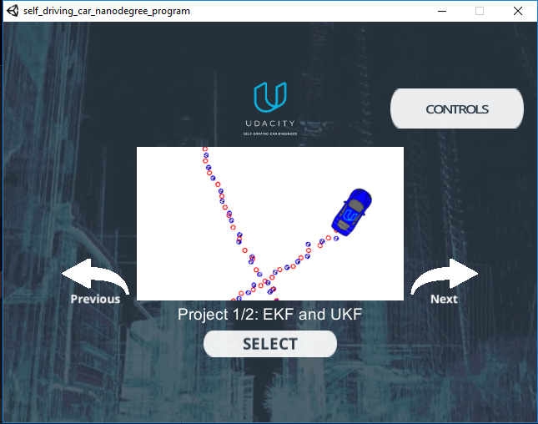

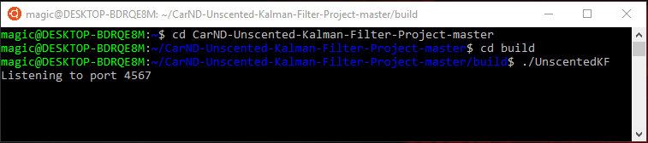

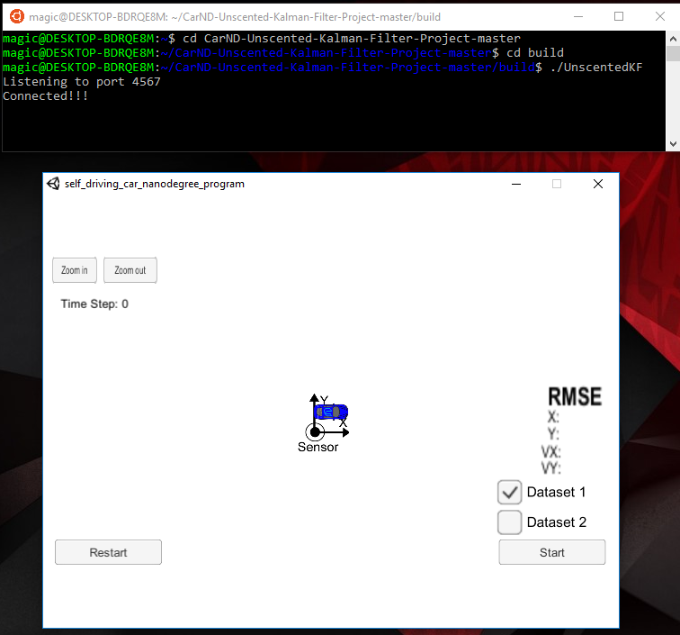

In the end, this is the result:

